Part B: Review of outcomes in the previous academic year. This details the impact that our pupil premium activity had on pupils in the 2024 to 2025 academic year.
Activity | Forecast (updated budget) – February 2025 | Actual spend to date (Sep to 31st Jan 25) End of Year figures TBC | Planned Yearly Budget June 2024 | End of Year Impact Report 2024-2025
Teaching and Support Staff (including CPD) | £39,707  £1280(CPD)  £13,644.13 (Inclusion Staffing)  £7,831  (Teachers)  16,562 (TA Support) | £533  £5,685  £3,263  £7,329 | £52,883  £1,520  £17,399  £9,927  £24,037 | CPD allowed upskilling staff and providing further training in a range of subjects, both subject based and in the areas of pastoral/ inclusion. This ultimately allowed improved academic outcomes and wellbeing support for disadvantaged students.  The Inclusion Team worked closely with PP students, particularly those with SEND, EAL, and behavioural difficulties, to remove learning barriers. Through collaboration with external agencies, they provided holistic, tailored support. Personalised strategies, including behaviour interventions, attendance support, and well-being programs such as East to West, helped students stay engaged and supported.  Teachers delivered Quality First Teaching with high expectations and tailored support for PP students. They identified learning gaps and implement targeted interventions to accelerate progress. By fostering strong teacher-student relationships, they enhanced motivation, confidence, and engagement, particularly for students who may lack support at home. Lessons were continuously adapted to provide personalised academic support, improving literacy, numeracy, and critical thinking. This individualised approach supported academic success and raised pupils’ self-esteem and aspirations.  Support staff played a key role in both academic reinforcement and emotional well-being. Teaching Assistants (TAs) worked one-on-one with students and lead small-group interventions, particularly in phonics and maths. These targeted efforts helped PP students close learning gaps while building confidence, resilience and emotional regulation.
Targeted Academic Support (resources and interventions) | £500 | £0 | £500 | This funding was used to pay for school funded Rocksteady placements where pupil premium children were selected to participate. This helped our vulnerable children build confidence and learn a new instrument / singing skills. This initiative nurtured their creativity and empowered them to thrive through music.  The decision to use this money to pay for Rock Steady was driven by pupil voice, where children expressed a strong interest in learning an instrument or singing in a band.
Wider Strategies (related to attendance, behaviour and wellbeing) | £8,395.13  £5700.23 (ELSA)  £2694.90 (Home Link Worker) | £2,375  £1,123 | £8,257  £5,625  £2,632 | Our wider strategies addressed non-academic barriers to learning, helping PP pupils to fully engage in their education. The ELSA (Emotional Literacy Support Assistant) and Home Link Worker played key roles in improving attendance, behaviour, and well-being. The ELSA supported pupils with emotional regulation, anxiety, and social challenges, boosting confidence and classroom engagement. Meanwhile, our Home Link Worker supported families with attendance, routines, and well-being, leading to improved punctuality, fewer absences, and increased parental involvement.
Voucher Scheme (trips, clubs and uniform) | £1,500 | £406 | £2,000 | The Voucher Scheme provided PP pupils with equal access to trips, extracurricular clubs, and school uniform, helping to remove financial barriers to participation. This initiative promoted social inclusion and enhanced engagement. Trips broadened pupils’ experiences and supported learning beyond the classroom, while clubs offered opportunities to develop new skills, build confidence, and improve well-being. Uniform vouchers ensured pupils had appropriate attire, reducing stigma and fostering a sense of belonging. The scheme boosted confidence and encouraged active participation in school life. By eliminating financial barriers, PP pupils accessed a wider range of experiences, which supported both their social and academic development.  Club participation was closely monitored to identify pupils who were not attending extracurricular activities, allowing us to create further opportunities for them. Some Pupil Premium vouchers remained unspent, so regular reminders were sent to parents to encourage full use of the funding.
Staffing – nursery (EYPP) | £3,194 | £1,331 | £1,469 | This allowed EYPP children to gain more individual support through improved staff-to-child ratios. Consistent staffing also helped create stronger relationships, boosting children's confidence and development.
PP funding 2024-2025  EYPP  Additional CLA / PLAC  Total  Adjustment to Income | £49,713  £3194  £0  £52,907 | £20,714  £1,331  £0 | £63,640  £1,469 | CLA and PLAC children joined in January 2025. Their funding was used to support staff-to-child ratios. Consistent staffing also helped create stronger relationships, boosting children's confidence and development.
Total | £52,907 | 22,045 | £65,109

Pupil Premium Activity  RAG Rating | Comment
Improve quality first teaching. Provide quality targeted CPD for teachers to ensure they have the skills and knowledge, enabling them to provide high quality education for all. | Achieved and Ongoing: Teachers accessed targeted CPD opportunities through internal and external training. This enhanced knowledge and skills, impacting on quality first teaching across the school. Leaders were able to identify gaps and next steps, which have been implemented on to the new SDP.
Continue to identify barriers for learning and set aspirational targets for children. | Achieved and Ongoing: Teachers continued to identify barriers to learning and set aspirational targets for pupils through both formative and summative assessments. This proactive approach allowed for informed discussions during pupil progress meetings. Tailored interventions, such as Phonics and Maths sessions, addressed learning gaps led by a teacher working across the school. In addition, high-quality books were gifted to all PP pupils to foster a love of reading.
To continue to strengthen whole school ethos and vison for disadvantaged. | Achieved and Ongoing: Staff had a strong understanding of the needs of disadvantaged pupils. To enhance this, vulnerable group registers were introduced in September, providing a clear overview of specific needs within each class. This initiative reinforced the whole-school ethos of supporting disadvantaged pupils. Furthermore, disadvantaged children were discussed in depth during Pupil Progress Meetings to ensure their gaps were closing
Internal interventions – additional reading, phonics and/ or maths using comprehensive materials. | Achieved and Ongoing: Interventions, including additional Reading, Phonics and Maths, were reviewed and planned by Year Team Leaders (YTLs) based on data analysis and Pupil Progress Meetings. PP pupils were prioritised by the Senior Leadership Team (SLT), YTLs and class teachers to ensure they received the best support for academic progress.
Provide pastoral support through ELSA to PP pupils, where needed. | Achieved and Ongoing: ELSA provided tailored support through 1:1 and group sessions, with additional assistance extended through parent calls and resources sent home. This approach had a positive impact on pupils’ and families’ social, emotional, and mental health (SEMH). 29% of Pupil Premium pupils received support from ELSA, contributing to their emotional well-being and engagement in school.
Provide Drawing for Talking Therapy to PP pupils, where needed. | Achieved and Ongoing: This intervention is designed for children unable to access ELSA intervention. It provides short-term therapy to help process trauma and emotional difficulties. The Drawing for Talking intervention was used by two pupils, neither of whom are PP but it was highly effective for the pupils who completed it.
Provide pastoral support through HSLW to PP families, where needed. | Achieved and Ongoing: The Home School Link Worker (HSLW) provided tailored support to vulnerable Pupil Premium pupils and their families, which was well received. 59% of PP pupils and their families benefitted from this support, leading to improved engagement and well-being.
Inclusion Service supporting school and working with vulnerable families to improve attendance  Awaiting Spring 2 and summer information. | Ongoing: There is now no external Inclusion Service supporting the school therefore the school has created its own internal inclusion team using staff. PP attendance is 2.7% lower than overall attendance and 0.1% lower than national attendance. However, the gap is improving and is being closely monitored. The Inclusion Team, HSLW, class teachers, and SLT have been working with individual students and families to improve attendance.  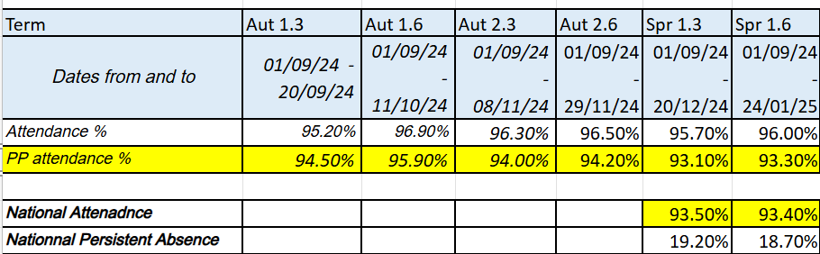
Supporting families’ financially – voucher scheme  Each Pupil Premium child is issued with a £25 voucher per term – total across the year is £75 per child. | Achieved / Ongoing:  The Total Pupil Premium funds available to spend for the Year was £2550. There was £1554.79 to be used in Summer Term (some carried funds over from Autumn and Spring, while some families overspent). 21 children used all or part of their voucher (62%)  £357.90 used towards trips – 42%  £43.6 used towards Clubs – 5%  A total of £1153.29 was not spent (45%)  1 child did not spend any of their voucher  PP families will be reminded about how much they have to spend again in the new year and this will be monitored closely to ensure all families are using their vouchers. Reminders were sent throughout the 2024-2025 academic year there other ways to support parents in spending their vouchers will be explored in the next academic year.  Attendance at clubs was monitored closely this year, and it was noted that many PP children did not attend any extracurricular activities. As a result, a new, free lunchtime board game club was introduced to give them the opportunity to take part. Further opportunities for PP children to engage in a wider range of extracurricular activities will be explored in the next academic year. Rock Steady funded places were also given to 7 PP children to support more of them to participate in an extra-curricular activity.
Forest school for pupil premium children | Achieved and ongoing: All PP children completed Forest School, which had a positive impact on their wider experiences, life skills, and promoted mental health and resilience.
Rock Steady extra-curricular Club in school | Achieved  7 children were given school funded places / bursaries to access Rocksteady. This allowed some of our vulnerable children to build confidence and learn a new instrument.

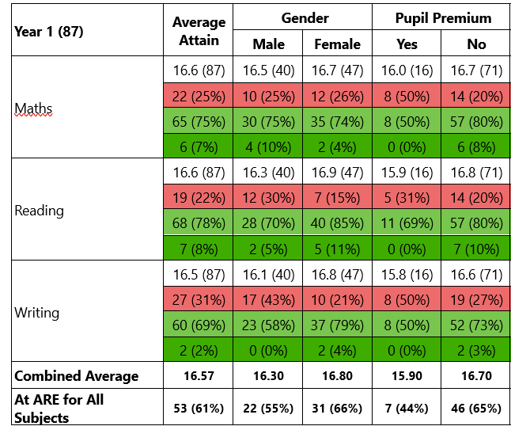
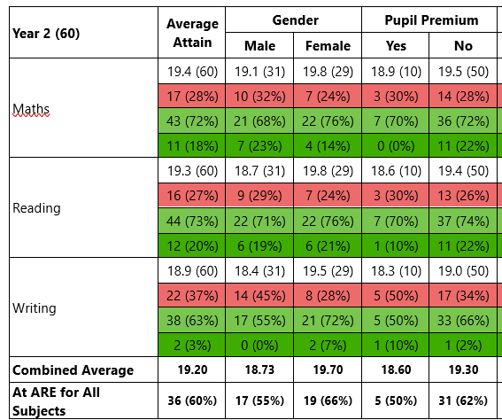
Summer 2025 Attainment Results

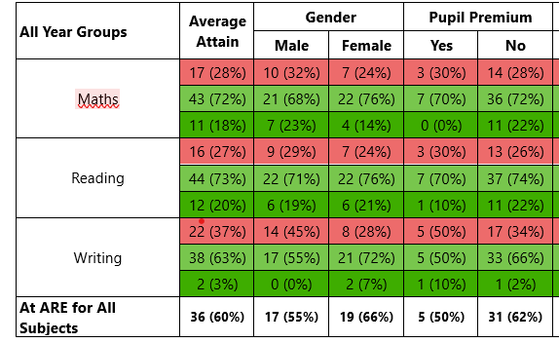
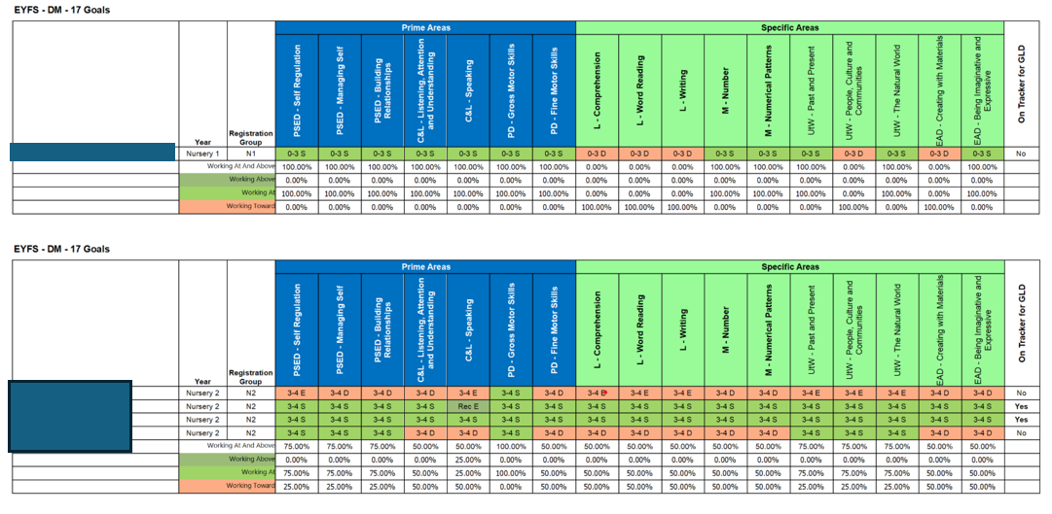
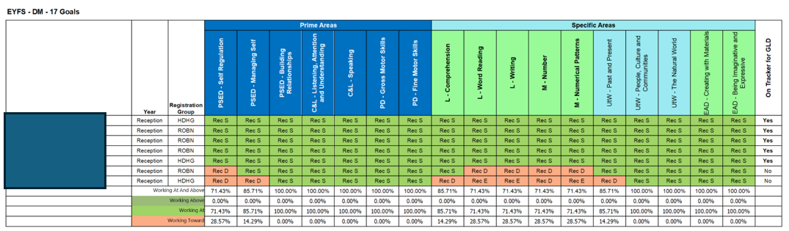
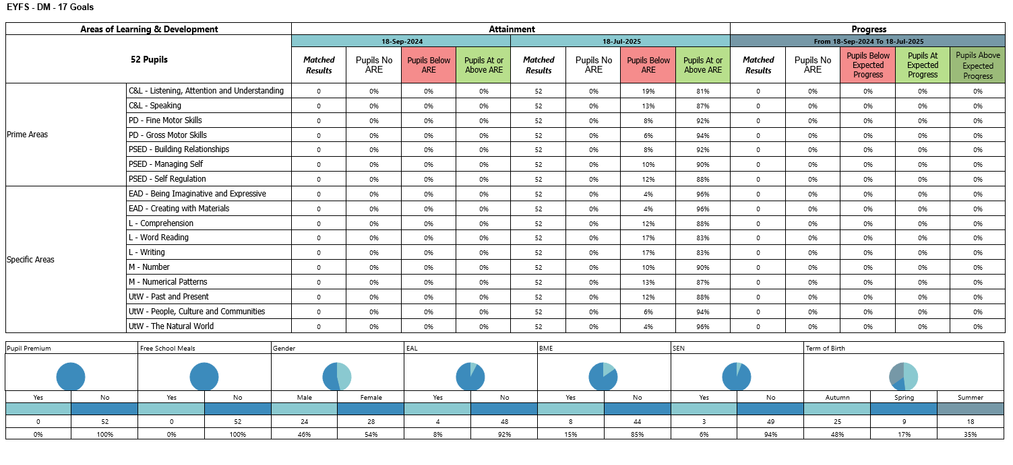
Reception (no PP)

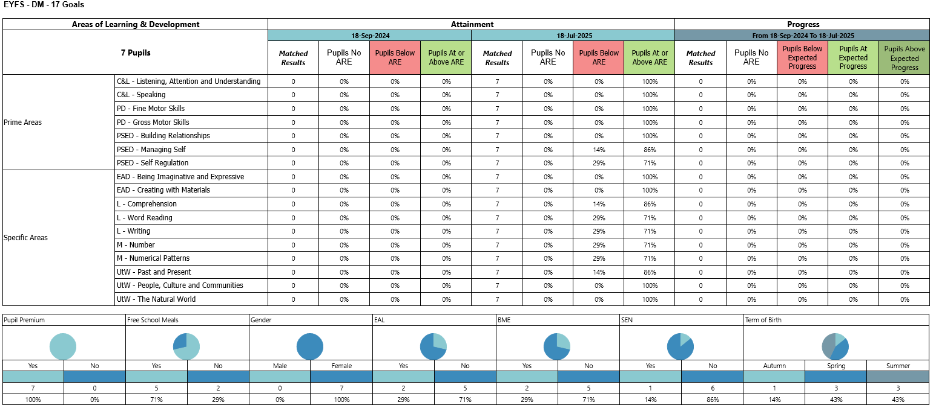
Reception (PP)

Externally provided programmes
Please include the names of any non-DfE programmes that you purchased in the previous academic year. This will help the Department for Education identify which ones are popular in England
Programme | Provider
N/A
N/A

Service pupil premium funding (optional)
For schools that receive this funding, you may wish to provide the following information:
Measure | Details
How did you spend your service pupil premium allocation last academic year? | N/A
What was the impact of that spending on service pupil premium eligible pupils? | N/A

