Part B: Review of outcomes in the previous academic year. This details the impact that our pupil premium activity had on pupils in the 2024 to 2025 academic year.
Activity | Actual spend to date (Sep to 31st Jan 25) End of Year figures TBC | Planned Expenditure | End of Year Impact Report 2024-2025
Teaching and Support Staff (including CPD) | £31,284  £726 (CPD)  £5,700 (Inclusion Staffing)  £12,804 (Teaching)  £12,054 (Teaching Assistants) | £73,022  £1,742  £17,399  £24,066  £29,815 | CPD allowed upskilling staff and providing further training in a range of subjects, both subject based and in the areas of pastoral/ inclusion. This ultimately allowed improved academic outcomes and wellbeing support for disadvantaged students.  The Inclusion Team worked closely with PP students to identify and address barriers to learning, particularly for those with SEND, EAL and behavioural difficulties. By collaborating with external agencies, they provided holistic, personalised support. Interventions such as behaviour strategies, attendance support and well-being programs allowed students to stay engaged in education. Mental health interventions improved emotional regulation and participation in lessons, while attendance support reduced absences, leading to better engagement and increased confidence. Overall, targeted support ensured that PP students had the emotional and academic stability needed to succeed.  Teachers delivered Quality First Teaching with high expectations and tailored support for PP students. Through formative and summative assessments, they identified learning gaps and implemented targeted interventions to accelerate progress. Strong teacher-student relationships fostered motivation, confidence, and engagement, particularly for PP students who may lack support at home. By continuously adapting lessons to meet individual needs, teachers improved literacy, numeracy, and critical thinking skills, raising attainment and boosting self-esteem and aspirations.  Teaching Assistants (TAs), played a key role in reinforcing learning and providing emotional support. They delivered one-to-one and small-group interventions, particularly in phonics and maths, helping PP students close learning gaps while building confidence, resilience, and emotional regulation.
Targeted academic support (resources, interventions) | £0 | £500 | This funding was used to pay for school funded Rocksteady placements, where pupil premium children were selected to participate. This helped our vulnerable children build confidence and learn a new instrument. This initiative nurtured their creativity and empowered them to thrive through music.
Wider strategies (for example, related to attendance, behaviour and wellbeing) | £2,913  £1,790 (ELSA)  £1,123 (Home Link Worker) | £6,857  £4225  £2,632 | Our wider strategies addressed non-academic barriers to learning, helping many PP students to engage fully in their education. The ELSA (Emotional Literacy Support Assistant) supported students with emotions, anxiety and social challenges, improving confidence and classroom engagement. The Home Link Worker supported families with attendance, routines and well-being, leading to better punctuality, reduced absences, and increased parental involvement.
Voucher scheme (trips / residentials, clubs and uniform) | £1,621 | £2,500 | The Voucher Scheme ensured PP students had equal access to trips, extracurricular clubs and school uniform, helping to remove some financial barriers to participation. This initiative allowed pupils to have increased engagement and social inclusion. Trips and residentials allowed pupils to broaden experiences, enhancing their personal development and motivation, while clubs offered opportunities to develop new skills, build confidence, and improve well-being. Uniform vouchers ensured all PP students had appropriate school attire, reducing stigma and fostering a sense of belonging. Overall, the scheme encouraged active participation in school life and contributed to improved engagement, social development and academic outcomes.
PLAC | £0 | £2570 | Although we had two PLAC children on role, we only had 1 child on budget due to the other child not being on role during the census for when this budget was created.  The PLAC child we had funding for benefitted from working with a 1:1 or 1:2 ratio within class daily. He also received OT interventions provided by a TA as well as daily comprehension and 1:1 maths support. He was also awarded the bursary Rock Steady placement.
Total | £35,818 | £85,450
Adjustment to Planned Expenditure |  | £85,450+£5,654  = £91,104 | Adjustment due to extra CLA child and number of PP have gone up slightly since budget
Total | £35,818 | £91,104

Pupil Premium Activity  RAG Rating | Comment
Improve quality first teaching. Provide quality targeted CPD for teachers to ensure they have the skills and knowledge, enabling them to provide high quality education for all. | Achieved and Ongoing: Teachers accessed targeted CPD opportunities through internal and external training. This enhanced knowledge and skills, impacting on quality first teaching across the school. Leaders were able to identify gaps and next steps, which have been implemented on to the new SDP (e.g. handwriting focus in English).
Tracking of interventions and support more closely using the Provision Map tool Edukey for children who are SEND and PP. | Ongoing: Targeted interventions for PP students, including Phonics, Fresh Start, Writing and Maths sessions were tracked by Year Team Leads (YTLs) and Class Teachers. Teachers identified learning barriers, set aspirational targets, and discussed progress during pupil progress meetings and PPA meetings effectively. However, the use of Edukey to monitor and track interventions was inconsistent across the school, as not all interventions were recorded and tracked on the system. This is something that will be focused on in 2025-2026.
To continue to strengthen whole school ethos and vison for disadvantaged. | Achieved and Ongoing: Staff have strong understanding of the needs of disadvantaged pupils. To support this, vulnerable group registers were introduced in September 2024, providing teachers with a clear understanding of specific needs within their classes. This initiative reinforces the whole-school ethos and vision for supporting disadvantaged students. To ensure the information remains current, teachers will be reminded of the registers in September 2025 and supported in updating them as necessary.
Reading volunteers targeted to support disadvantaged readers. | Achieved: All year groups had reading volunteers to support their bottom 20% readers. This positively impacted pupils’ reading skills and boosted their enjoyment.
Internal interventions – additional reading & comprehension materials. | Achieved and Ongoing: Additional interventions were implemented where needed, including Fresh Start, RWInc Phonics, handwriting, maths and comprehension skills. These were closely monitored by YTLs and teachers and progress of individual children was discussed in Pupil Progress Meetings. The interventions supported closing gaps for most children and helped them make progress.
Provide support through ELSA where needed. | Achieved and Ongoing: ELSA provided tailored, personalised support through 1:1 and group sessions. Support was extended through parent calls and resources being sent home. This approach has had a positive impact on pupils’ and families’ SEMH (Social, Emotional, and Mental Health). 29% of PP children received support from the ELSA, contributing to their emotional well-being and overall engagement in school.
Inclusion service supporting school and working with vulnerable families to improve attendance.  Spring and Summer to be added – awaiting for information. | Ongoing: Spring 1 - PP attendance is 4.4% lower than overall attendance and 3.3% lower than national attendance. However, the gap has improved between Spring 1.3 and Spring 1.6, and this continues to be closely monitored. The Inclusion team, HSLW, class teachers and SLT are working with individual students and families to improve attendance.  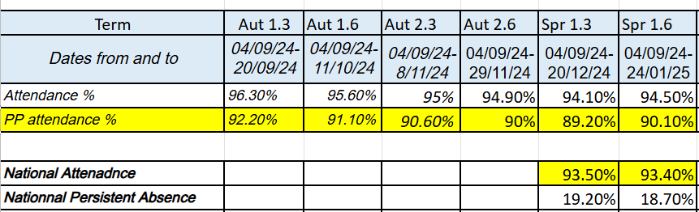
Supporting families’ financially Voucher Scheme: £30 a year voucher provided to pay towards trips, clubs or uniform. Additional £75 available to pay towards residentials in Years 4,5 and 6. | Ongoing  Across the academic year, The Hermitage Junior School issued 68 children with vouchers for £30 – Total possible spend £2040. 49 children were in Year 4 – 6 and were entitled to a further £75 each towards the years residential trip, totalling £3675. Total Pupil Premium funds available to spend was - £5715.  Vouchers used in the Summer Term:  6 children started to use their voucher during the summer term and a further 28 children continued to use the funds from their voucher. A total of £477 was allocated over the summer term – 23.38% of total available.  58 children used part or all of their voucher – 85.29% of vouchers had been used (only 14 vouchers were used in full).  A total of £1284.59 was used - 62.97% of voucher value used. 14 children Pupil Premium children were booked on a residential, all of whom had additional funding , totalling £1050 - 28.57% of potential.  - £285 used towards Clubs  - £999.59 used towards Trips  - £1050 additional funding used towards residential  - £2334.59 total Pupil Premium used  Voucher were actively monitored and reminders were sent to parents to encourage eligible families to use them. However, a significant amount was still not spent therefore we will be considering ways in which we can ensure more of our vulnerable families spend the money they are eligible to utilise.  £451.28 was spent on providing school dinners for a child with an allergy that Twelve15 was unable to cater for. This ensured the child received a nutritious lunch during the school day.  Attendance at clubs was monitored closely this year, and it was noted that many PP children did not attend any extracurricular activities. As a result, a new, free lunchtime board game club was introduced to give the children an opportunity to take part. This helped build social skills including turn taking and playing different types of board games. Further opportunities for PP children to engage in a wider range of extracurricular activities will be explored in the next academic year.
Music lessons offered to those who want to take part- individual and Rocksteady. | Achieved: 8 children (including one PLAC child) were given school funded places / bursaries to access Rocksteady. This allowed some of our vulnerable children to build confidence and learn a new instrument.
Drawing for Talking trained staff deliver interventions to support learners. | Achieved and Ongoing: 4 children accessed this intervention, one of whom is PP. The intervention is designed to provide a safe, short-term therapy to help process trauma and emotional difficulties, particularly benefiting the PP child.
Forest school for pupil premium children | Achieved and Ongoing: Forest School had a positive impact on pupils' wider experiences and enhanced their life skills. It promoted positive mental health and resilience for some pupils. Next year, the Forest School Lead will aim to select PP who have not completed Forest School to do this first.
General parental engagement and wellbeing of children and families (uniform, devices, open door). | Achieved and Ongoing: The HSLW has provided tailored support for vulnerable PP children and their families, which has been well received. Over the year, 37% of PP children and their families benefited, leading to improved engagement and well-being.  Additionally, high-quality books from our library were gifted to all PP children to foster a love of reading in the autumn term.  A free lunchtime board game club helped PP children, who wished to attend, to build their social skills, build friendships, and develop confidence in a fun and supportive environment. This also gave our PP children, who do not access any clubs an opportunity to do an extracurricular activity.
Supporting PLAC children in school to achieve the best that they can. | Achieved and Ongoing: There were two PLAC children. One child received support through a 1:2, 1:3 Teaching Assistant ratio throughout the school day, while the other worked closely within a small adult led group. Both children had engagement from outside agencies to discuss their needs with the inclusion team, and one child accessed the Kindness Christmas Voucher through our Home Link Worker. Both children were well supported and enjoyed school. Additional interventions, such as OT, participation in the bottom 20% reading groups, and various other support measures such as adapted work and wellbeing support was also beneficial and supported the children to gain confidence and close some gaps within their learning. One PLAC child was given a bursary placement to participate in Rock Steady which greatly supported the child’s confidence and social skills.

Summer 2025 Attainment Results
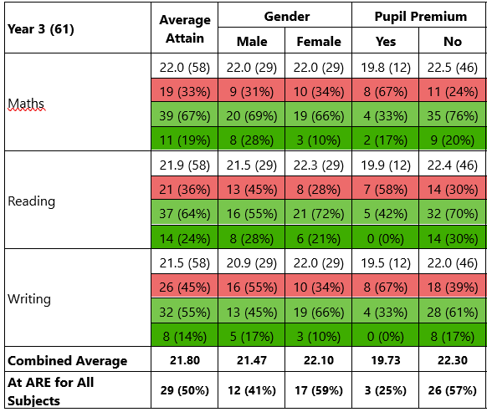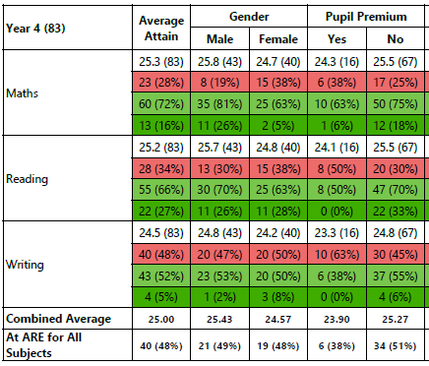
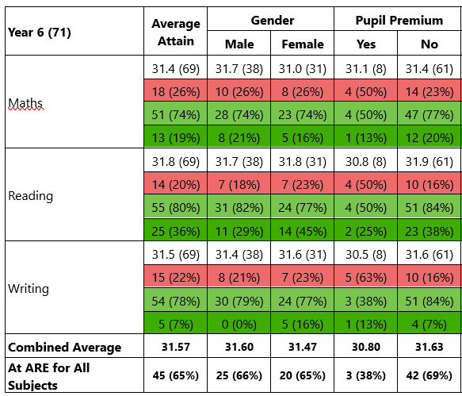
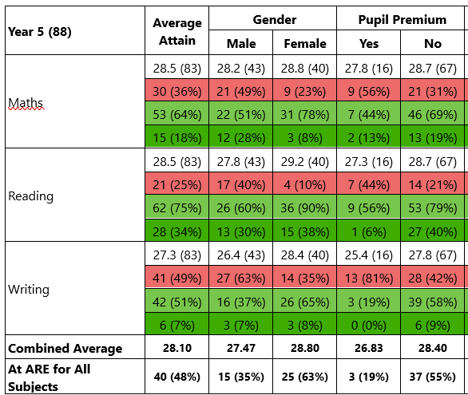
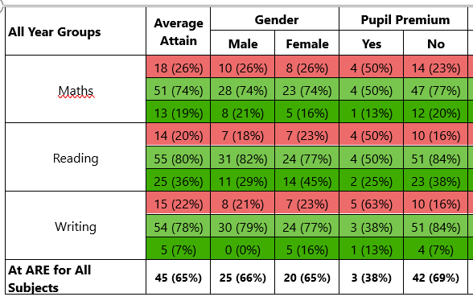

Externally provided programmes
Please include the names of any non-DfE programmes that you purchased in the previous academic year. This will help the Department for Education identify which ones are popular in England
Programme | Provider
Reading Eggs | Reading Eggs
Book in a Box | Book in a Box

Service pupil premium funding (optional)
For schools that receive this funding, you may wish to provide the following information:
Measure | Details
How did you spend your service pupil premium allocation last academic year? | N/A
What was the impact of that spending on service pupil premium eligible pupils? | N/A

