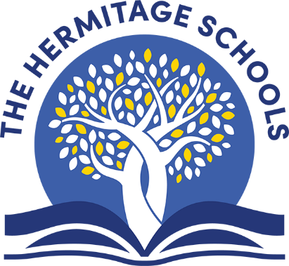

|  |  |
| --- | --- |
| **Book Title** | **Author** |
| Bear Called Paddington | Michael Bond |
| Amazing Grace | Mary Hoffman |
| Avocado Baby | John Burningham |
| Charlie and Lola | Lauren Child |
| Frog and Toad are Friends | Arnold Lobel |
| Hairy Maclary (and collection) | Lynley Dodd |
| Katie in London | James Mayhew |
| Lost in the Toy Museum: An Adventure | David Lucas |
| Mister Magnolia | Quentin Blake |
| Mr. Men in London | Adam and Roger Hargreaves |
| Mrs Armitage on Wheels | Quentin Blake |
| My Friend Bear | Jez Alborough |
| No Place Like Home | Jonathan Emmett |
| Old Bear | Jane Hissey |
| Room on the Broom | Julia Donaldson |
| The Cat in the Hat | Dr. Seuss |
| The Gigantic Turnip | Aleksei Tolstoy |
| The Highway Rat | Julia Donaldson |
| The Large Family Collection | Jill Murphy |
| The Paper Dolls | Julia Donaldson |
| The Princess and the Pea | Minnie Grey |
| The Smartest Giant in Town | Julia Donaldson |
| The Tiger Who Came to Tea | Judith Kerr |
| The Trouble With Jack | Shirley Hughes |
| Topsy and Tim Visit London | Jean and Gareth Adamson |
| Toys in Space | Mini Grey |

**Recommended Reading List – Year 1**